MTM Youth Services CIC
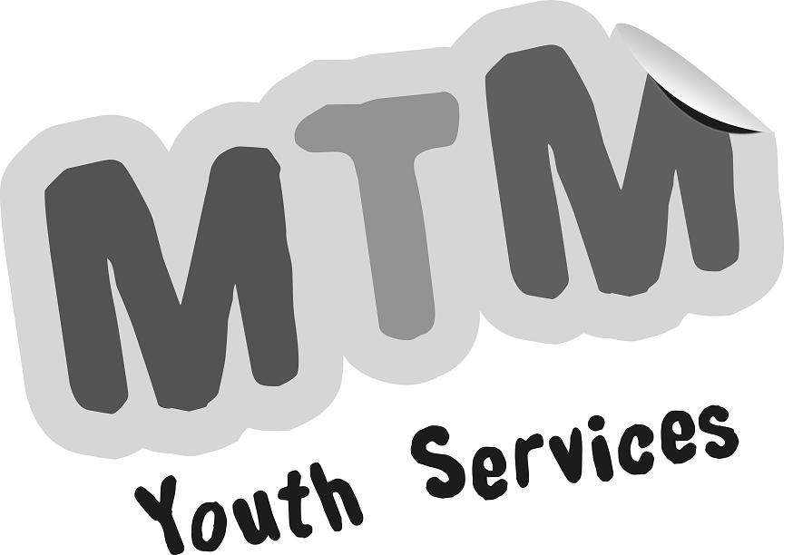

Parent/Carer Consent Form for Young People

SNYAB First Aid Course Visit Organiser: Sam Mason Telephone: 07778 896325

Place/s of Visit: Ayton House, 11 Ayton Road, Wymondham, NR18 0QQ

Date of Departure: Thursday 22nd February 2024

Time: 9.30am – 4.30pm

Activities to be undertaken: Basic First Aid - tutored course

Do you need transport? YES⃝ NO⃝ (Can only be provided from South Norfolk addresses)

Method of Travel: Taxi / Car if needed Seatbelts fitted as standard: Yes

Young Person
First Name …………………….…...Surname ……….….….….…male/female/other………….…

Date of Birth …………………… Address: ………………………………………….……….……

…………..……………………………….………………...………..…….. Postcode ………….……

Telephone: Home …………………………………....Mobile ……….………………………….….

Email address: ……….…………………………….………………………..….

Medical History
Please give details of any recent illnesses, or contact with any infectious disease within the last month:

………………………………………………………………….……………………………………….
Please give names and dosages of any medications being taken (These must be handed to the Lead Youth Worker):

………………………………………………………….…………………………….…………………
Please tell us about any allergies, e.g. medicines, food, drink, bee stings, etc, to be avoided:

………………………………………………………….…………………………….…………………
Please provide any other information which you feel might be useful in an emergency or that the Visit Leader should be aware of (e.g. phobias, epilepsy, hyperventilation, disability, diabetes, travel sickness, period pains, toileting difficulties, friendship problems, etc):

………………………………………………………………………………………………….…….…

Doctor’s Name and Telephone Number:……………………………………………………………

Doctor’s Surgery Address…………………………………………………………………………….

National Health Number (if known)………………Date of anti-tetanus injection ………………..
Diet
Please indicate any restrictions on diet, e.g. vegetarian, vegan, diabetic, allergies (behavioural, hyperactivity, etc.)

Painkillers
Do you agree to the above named young person receiving pain-relieving medication when appropriate (one dosage of Paracetamol only)?

 Yes I agree K  No I do not agree Please tick where appropriate

Parent/Carer Details - A contact number for use in emergencies must be given
Full Name: ……………………………………………..……………………………………………….

My address during the period of the course will be:

Address: ………………………………………………………………………………………………..

………………………………………………………………………. Postcode………………………

Telephone………………………………….…Mobile Telephone …………………………………

Work Telephone…………………………… Other Telephone……………………………………

If you would like to be kept informed about future youth activities, please tick box and write your email address clearly below

…………………………………………………………………………………………………………...……

Alternative Parent/Carer Details
Full Name: ……………………………………………..……………………………………………..

Their address during the period of the course will be:

Address: ……………………………………………………….……………………………………..

…………………………………………………………..……………. Postcode……………………

Telephone…………………………………Mobile Telephone ……………………………………

Work Telephone…………………………..Other Telephone………………………………………

- I am willing for my child to take part in the above visit/journey, and having read all the information provided, I agree to his/her taking part in the activities involved.

- I fully understand that, while the supervisory adults in charge of the group will take all reasonable care of the young people, neither they, nor MTM Youth Services CIC, can necessarily be held liable in respect of loss or damage to property or injury suffered by my child arising out of the educational visit/journey, unless such loss, damage or injury results from the negligence of MTM Youth Services CIC, its staff or official volunteers.

- I agree to my child/ward receiving medication as instructed and any emergency dental, medical or surgical treatment, including anaesthetic or blood transfusion, as considered necessary by the medical authorities present.
I confirm that I have parental/carer responsibility for this young person.

Signed: …………………………………..…….. Relationship …………………………………

Please print name: ………………………….. Date: …………………………….…………..…

Should there be any amendments to this form after it has been handed in, please contact the
Lead Youth Worker immediately.

The above information will be stored on database and will be used for the administration and delivery of activities being organised by MTM Youth Services CIC to monitor statistical information for the visit and for no other purpose, in accordance with the Data Protection Act (1988). All personal information will be held in the strictest confidence. It will not be made available to any third party other than those directly involved in the organisation and delivery of visit activities. Consent Forms will be destroyed securely by means of shredding one year after the Activity has finished. A copy of our Privacy Policy is available on www.snyab.org

Photography
During the course of the project there may be opportunities to publicise some of the activities that the young people are involved in. This may well involve filming or photographing young people for use in the local media; we welcome these opportunities and hope that you do too. There may also be occasions when we arrange photography for our own purposes, such as displays, our website and publicity brochures. Photography or filming will only take place with the permission of each young person’s Lead Youth Worker and under their supervision. When filming or photography is carried out by the news media, which will only be authorised by the Lead Youth Worker, young people will only be named if there is a particular reason to do so (e.g. they have completed a specific activity or achieved an award). Home addresses will never be given out. There may be other circumstances, falling outside the normal day to day activities of MTM Youth Services CIC, in which pictures of young people are requested. The Lead Youth Worker recognises that in such circumstances specific consent from parent or guardian will be required before they can permit photography or filming of young people. All photographs will be destroyed securely either electronically or by means of shredding one year after the Activity has finished. If you would like disposal to take place before one year has passed please contact us and we will action your request.

I understand that images may be taken of the above named young person as follows:
- By the local media in covering programme activities that show the programme and young people in a positive light, e.g. participating in activities, sports, prizegivings, etc.
- By photographers acting on behalf of the programme for use in displays and publicity material.

Having read the statement above, do you give your consent for photographs or other images to be taken and used? (please tick the appropriate box) |  | YES, I give my consent for pictures to be taken and used
 |  | NO, I do not give my consent for pictures to be taken and used
.

