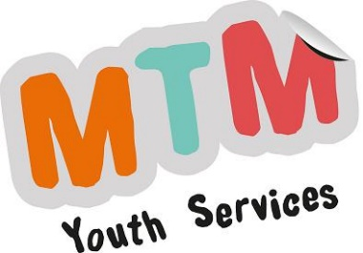
MTM Youth Services CIC
Head Office
1 Rambler Cottage
The Street
Botesdale
Suffolk
IP22 1BZ

07778 896325
info@mtmyouthservices.org.uk
24.1.2024

First Aid Course

Venue: Ayton House, 11 Ayton Rd, Wymondham NR18 0QQ
Date: Thursday 22nd February 2024 Time: 9.30am – 4.30pm

Hello,

South Norfolk Youth Advisory Board (SNYAB) is funding this First Aid Course for young people aged 12 – 19 years, and who live in South Norfolk, or go to school in South Norfolk. Accredited courses which support young people to develop skills have been identified as important by the YAB. Everyone who passes will receive a certificate which is valid for three years.

If you would like to attend, please post the completed consent form to MTM at the address at the top of this letter at least five working days before the session. If we have not received a signed form through the post (no emails, scans or photos), you will be unable to attend. Places are limited, so will be allocated on a first come, first served basis.

There is some moving about with this course while you demonstrate your skills, so make sure that you are dressed appropriately. A light buffet lunch and refreshment will be provided. Please ensure that you state any dietary requirements / preferences on the consent form.

We are able to offer transport to the session if you cannot get there yourself, and you live in South Norfolk. However, this may be shared with another young person, and you may be expected to wear a face covering or mask on the journey. Please only request transport if you really need it.

Please visit www.mtmyouthservices.org.uk for further information about:

- Why we need consent forms
- Taxi journeys for our activities
- MTM Youth Service's current Covid-19 Policy for Young People

If you find that you can no longer make this course, please let us know as soon as possible. There are always waiting lists, and we can offer your place to someone else.

Yours faithfully,

Sam Mason
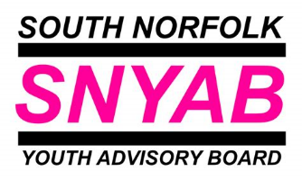
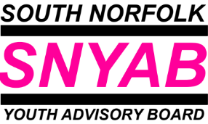
SNYAB Youth and Community Worker

