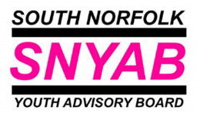
South Norfolk Youth Advisory Board (SNYAB)
Consultation and Needs Analysis 2022

SNYAB has undertaken consultation in 2022, based on current YAB priorities; data gained through NCC’s Youth Strategy consultation; and the national and local results of Youth Parliament’s Make Your Mark campaign. There was also some local consultation undertaken in 2021 around open spaces in the district.
Between 21st June and 22 July 2022, SNYAB undertook a ‘deep dive’ consultation with 104 individual young people, across 14 different groups in schools and youth groups. These groups were held in seven school cluster areas around the district: Diss, Long Stratton, Harleston, Hethersett, Loddon, Wymondham and Framingham Earl. Young people were aged between 12 and 18 years old.
We split our conversations into different priorities, but it was inevitable that that they would overlap. Young people felt that the priorities were right, and made sense that SNYAB should focus on these areas.
SNYAB Priority: Health and Wellbeing
Without exception everyone consulted felt that mental health was a top priority for young people at this current time. Although many reasons were given for this, it was felt that Covid had not only impacted how young people felt, but also the services and spaces that they had previously accessed for support.
The word clouds give a flavour of the different discussions and topics that came out during the focus groups.
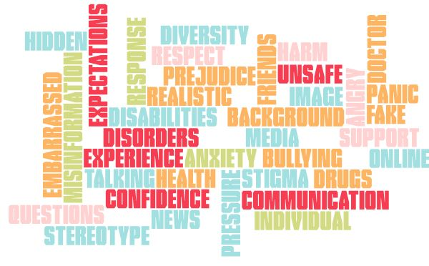
SNYAB Priority: How To Adult
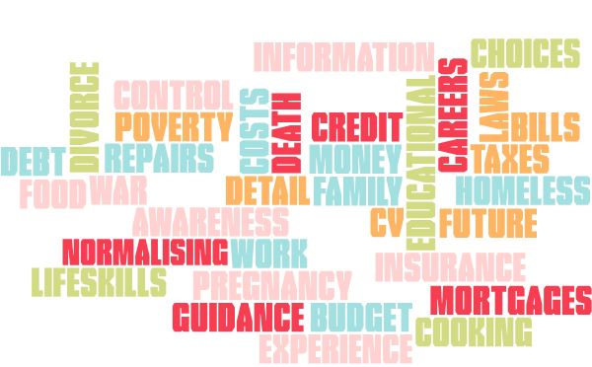

SNYAB Priority: Relationships with People and Your Community
