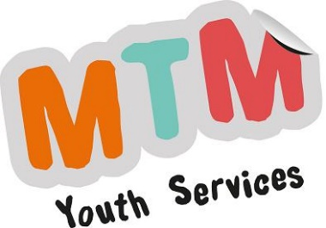
MTM Youth Services CIC
Head Office
1 Rambler Cottage
The Street
Botesdale
Suffolk
IP22 1BZ

07546 059061
julia@mtmyouthservices.org.uk
25.04.2023
SNYAB Clinks Farm Session

Venue: Clinks Care Farm, Eaton Farm, Church Road, Toft Monks, Beccles NR34 0ET
Date: Saturdays 20th May; 17th June; 15th July; 19th August
Time: 10.30am – 3.00pm & transport time (Young people can attend up to two dates of the four available)

Hello,

The South Norfolk Youth Advisory Board will be running sessions at Clinks Care Farm (https://clinkscarefarm.org.uk/) for young people aged 12 – 19 years. These sessions will consist of working with livestock, conservation, and market garden tasks. If you would like to attend, please post the completed consent form to MTM at the address at the top of this letter at least five working days before the session. If we have not received a signed form through the post (no emails, scans or photos), you will be unable to attend. Please see www.mtmyouthservices.org.uk for details about why we need Consent Forms.

The following rules & guidance will apply:

- Please bring your own drink & lunch
- As we will be working outside, it is essential that you come suitably dressed (no shorts), along with some sturdy outdoor shoes, preferably wellies. Be dressed for the weather with warm clothing & waterproofs if raining.
- Please bring your own gardening gloves where possible. If not, we will have some spare pairs available on the day.
- We have completed a risk assessment. Please let us know if you would like a copy.

We will operate under Covid Responsible Measures relevant at the time of the session.
- For further information about MTM Youth Service's current Covid-19 Policy for Young People, please visit www.mtmyouthservices.org.uk
- You will not have to wear a face covering but please do so, if it helps you to feel more comfortable.

We are able to offer transport to the session if you cannot get there yourself. However, this may be shared with another young person, and you may be expected to wear a face covering or mask on the journey. Please only request transport if you really need it. Please see www.mtmyouthservices.org.uk for more details about taxi journeys for our activities.

If you find that you can no longer make a session, please let us know as soon as possible. There are always waiting lists, and we can offer your place to someone else.

If you have any questions, please contact me, or the Lead Worker: Monika Baranowska-Zavanaiu Telephone: 07432 767854
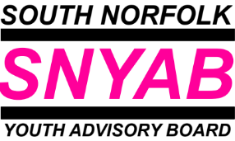
Yours faithfully
Julia Fairbrother,
SN YAB Youth & Community Worker

