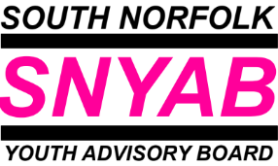
South Norfolk Youth Advisory Board (SNYAB)
Become a Young Commissioner!

What is a Young Commissioner?
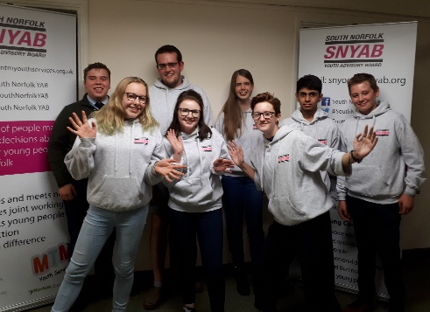
A young person who makes things better for other young people. Young Commissioners lead the Youth Advisory Board (YAB) to spend money, make change and influence people who make decisions.

What is the YAB?
The YAB is a group of people who find out what young people want and need, and do something about it. These people include health reps, police officers, teachers, youth workers and councillors.

What do Young Commissioners actually do?
They discuss quality of services, they make decisions and they develop links with others. They also run events and fund activities – leading to positive experience and change for young people.

How do Young Commissioners do that?
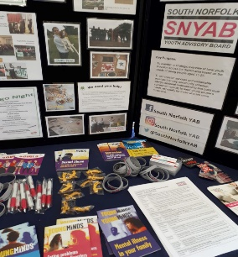
Young Commissioners get together every three weeks, in different places. Not all Young Commissioners come to every meeting, and not all get involved in other activities. Some work on interview panels, some go to full YAB meetings, some ensure funded activities are good, and some have got involved with other youth projects. Young Commissioners can commit as much or as little time as they like.

What do I need to be a Young Commissioner?
Enthusiasm and ideas! Training and support are offered to all young people. Young Commissioners are aged between 13 and 19 (up to 25 with additional needs) and live in South Norfolk. If you live outside of the district but want to be a Young Commissioner, let us know and we will put you in touch with the right people for your area.
Young Commissioners have fun when they get together – it’s a chance to make new friends, share ideas and develop new skills. Transport can be provided, there’s always snacks and drinks, and it’s all free!

More information can be found at www.snyab.org or contact Julia on
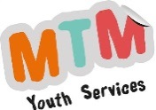
07546 059061. You could also email snyoco@snyab.org

